Andrew Wilhelm
May 29, 2007
The Breakthrough of Chicano Art
In 1972 members of a group of Chicano artists known as Asco quietly approached the Los Angeles County Museum of Art at night and spray painted their names on its outside walls. While spray painted walls are not an uncommon sight in Los Angeles this was not typical graffiti. It was not a senseless act of vandalism, nor was it related to any of the city’s gangs, this was an act of protest. Fed up with the museum’s complete lack of Chicano art in its galleries and apparent indifference to the growing movement the frustrated artists made the statement “We felt that if we couldn’t get inside, we would just sign the museum itself and call it our work” (Benavidez 18). This seemingly spastic act has surprisingly significant precedence. Fifty-five years earlier, in France, the Dada movement expressed its distain for a world which let itself slip into war and chaos, for example, Dadaist Marcel Duchamp purchased and signed a porcelain urinal and submitted it to the society of independent artists as his own work (Cross 47-50). Duchamp’s “image has since circulated as the most subversive icon of modernity” (Cross 48) and like Asco’s Graffiti it “expanded the notion of authorship” (Cross 48). The painting of the walls followed the tradition of the Mexican muralists and represented the space to which most Chicano Art was confined, outside of the collections of most galleries and museums until the 1970’s and 80’s. As Chicano art gained momentum during this period one sees the artistic traditions of Europe and Mexico combining and conflicting in individual works as artists expressed themselves while simultaneously catering to their American audience, thus, submitting to the culture of Los Angeles yet, simultaneously, staying true to their Mexican roots.
During the breakthrough of Chicano art in the late twentieth century the movement was divided into two major groups each with an up-and-coming artist at its forefront. The group Los Four was formed with the intention of bringing the attention of critics to the growing Chicano art scene. Los Four consisted of trained artists, most with advanced degrees in fine arts who took a unique but academic approach to painting. They hold the distinction of being the first Chicano artists to be shown at The Los Angeles County Museum of Art (Annett 1). Their most famous member, Carlos Almaraz, painted prolifically during his short life creating colorful and uniquely Chicano works which recall the styles of Monet and Van Gogh (Turner 49). Asco, an organization of "self-styled misfits and cultural radicals"( Benavidez 18) is best known for the work of its founding member Glugio Nicandro, better known as Gronk, “‘a Brazilian-Indian word that means ‘to fly’”(Marin 150). This self-taught painter and performance artist drew much of his inspiration from the graffiti and murals on the streets of his native East Los Angeles as well as popular Mexican art and the culture and politics of Southern California in the 1980’s (Benavidez 19).
Gronk seems to embody the rebellious and countercultural side of the Chicano art movement. Living in an impoverished Mexican-American community, largely cut off from the rest of the city, both culturally and geographically, he was often left alone as a child and found comfort, as well as a sense of escape, in books, art and television. This upbringing left the young artist with a sense of himself as an outsider, a feeling made stronger by his homosexuality. According to critic Daniel A. Olivas this background accounts for Gronk’s most recognizable image “the iconic ‘La Tormenta’ (figure 1) , who is always depicted facing away from the viewer. La Tormenta wears long black gloves and a matching gown that plunges in a deep “V” down her back…. La Tormenta can be seen as Gronk's glamorously stylish alter ego who is central to his artistic arsenal, that serves as a symbolic counterpoint of an 'authentic,' stable sexual identity” (1). Chicano art historian Max Benavidez makes a similar explanation for this mysterious figure in his essay “Chicano art: Culture, Myth and Sensibility” in which he states that “The case could be made that Tormenta is none other than Gronk himself, his anima, his feminine self, dressed to kill and to impress” (19). Surprisingly, the notion of sexual ambiguity in Mexican art was not unprecedented. In 1940, Mexican artist, Frida Khalo painted the deeply introspective Self Portrait with Cropped Hair. In this painting the artist sits alone in the center of a room, with short hair and clad in an ill-fitting men’s suit (Poda, Grimberg and Kettenmann 134). Like Gronk, Khalo creates figure to represent herself in an alternate sexual identity. One aspect of La Tormenta which is surprisingly overlooked by these critics is her distinct resemblance to Diego Rivera’s 1944 painting Nude with Calla Lilies (figure 2) , one of Mexican art’s most iconic images. The short, black hairstyle, hidden face and “V” shaped back of Rivera’s figure strongly resemble those of Gronk’s. Perhaps the figure not only represents a stable sexual identity but a stable and solid image of Mexican art. Perhaps, through La Tormenta, Gronk retains a cultural identity in his works as he begins to cater to the artistic tastes of a European-American audience.
While La Tormenta appears in countless works throughout Gronk’s career, the idea of her as a stabilizing force is exemplified in his 1998 piece La Tormenta Returns (figure 3) a colossal work, twelve feet long and eight feet high, which illustrates numerous aspects of the Asco school of Chicano art. Gronk painted the massive triptych, a work which covers three separate panels, before an audience with musical accompaniment by the equally counter-cultural Kronos string quartet (Marin 77). In the painting background and foreground merge into a solid surface, a characteristic element of Diego Rivera’s Epic of the Mexican People, another triptych mural, completed in 1935 (Kettenmann 60). Unlike Rivera’s mural, in which this fusion creates a sense of rigid solidness, Gronk’s piece blurs background and foreground into a scene of chaos and confusion reminiscent of Pablo Picasso’s Guernica, a painting of the bombing a Basque town which art historian Carsten P. Warncke calls “a gesture of profound emotion” (Warncke 149), a description also applicable to La Tormenta Returns. The central figure of the piece, La Tormenta, stands still as while surrounded by a sea a chaos, perhaps as a figure of a stable sexual identity or perhaps as a symbol of Mexican culture, establishing a solid presence in the United States. Her outstretched arms seem to grab hold of her surroundings, emphasizing the idea of stability while creating a pose resembling a crucifix. This central cruciform combined with the face that the work is a triptych, forces the viewer to note the piece’s similarity to the three-paneled altarpieces found in the numerous missions which dot the western coast of Mexico and California. The impressive scale and public nature of the piece immediately brings to mind the works of the Mexican muralists whose large public works characterized the Mexican art of the 1920’s and 30’s. The painting and performance seem to be a dramatic collision of European, Mexican and American styles with Gronk, in the form of La Tormenta acting as a stabilizing force, moderating the turbulence and creating a style which would come to be seen as uniquely Chicano.
Unlike Gronk, Carlos Almaraz of Los Four had a formal education in the arts; he obtained a master’s degree of fine arts in 1974. According to Max Benavidez “The key difference between the two was that while Gronk experimented with various persona and media, including performance and stage presentations, Almaraz was a painter in the classical sense” (20). Almaraz was born in Mexico City and spent his early life in the United States living in New York City, Chicago and most importantly East Los Angeles (Marin 148). Before his death from AIDS in 1989 he produced numerous paintings and drawings as well as poems and essays which have been published in more than fifty books and journals (Turner 49). His academic training in painting is evident in his 1982 work West Coast Crash (figure 4), like Vincent Van Gogh, Almaraz applies thick and heavy amounts of paint to the canvas, giving his work a sculptural quality. In West Coast Crash gobs of paint become flames and bits of debris flying off of the two dimensional surface of the canvas and into the world of the viewer while loose fast brushstrokes become the car’s tires spinning in the air. This painting shows a meticulousness and mastery of medium which is simply absent in the expressionistic works of Gronk.
Of all Almaraz’s works, most critics and historians agree that his Echo Park Series (figures 5-8) was his most important. This series of paintings, writings and pastel drawings created between 1979 and 1989, the last ten years of his life, was a very personal endeavor “Like Monet and his haystacks, Almaraz captured, from his apartment window, Echo Park in all its various incarnations, from serenely bucolic to hot, feverish and dangerous. Bathed in deep violets, hot pinks and bloodlike reds, this Echo Park was a place of beauty and mystery” (Turner 49). Although beautiful the images of trees and lakes at sunset have a sort of uneasiness about them, as if their tranquility is merely the eye of a storm. In his 1979 pastel drawing Glendale Blvd (figure 5) and his 1986 Suave Como La Noche (figure 6) distant, shadowy figures of buildings and trees loom over peaceful landscapes giving the viewer the unpleasant feeling of being watched while alone in the space of the park. The true nature of this uneasiness would be known only to those who had personally experienced Echo Park, the residents of the surrounding Chicano neighborhood. Max Benavidez explains; “Superficially, it’s hard to explain the horror inherent in the apparently romantic tranquility of the park. But when you know the environment in its real context, bordered on all sides by anxiety, poverty and oppression, the graceful images become omens of impending chaos. Almaraz foretells a dark fate lurking in the shadows and beneath the surface” (Benavidez 20). Echo Park Dusk, a pastel drawing from 1986, attempts to communicate this sense of being surrounded by danger. In this drawing an island, covered with gray palm trees, floats over a lake turned bright red by the setting sun and resembling fire. In this work Almaraz uses the island in Echo Park as a microcosm of Echo Park itself, isolated, an island in a lake of peril. The Echo Park Series is admired today not only for its ascetics and unique mood but for that fact that it has virtually come to define the Chicano art movement. In no other works from this time are the influences of America and Mexico so perfectly combined. Art critic Nancy Kay Turner explains; “These moody works show the influence of Munch's symbolist landscapes, the Fauve's color palette of pinks, oranges and blues, and Monet's brand of Impressionism, mixed in with Almaraz' own Hispanic sensibility” (Turner 49). His fusion of styles appeals to a wide audience while his subject matter is uniquely Chicano, during his short artistic career of twenty five years Carlos Almaraz managed to define a genre.
After the first exhibition of Chicano art in a major public institution, the Los Four exhibit at the Los Angeles County Museum of Art in 1974, the volume of Chicano art seems to explode in size in the nineteen seventies and eighties, it is as if as if a great pressure could no longer be contained. As can be seen in the works of Almaraz and Gronk art adapted to its new audience as it moved from the walls and streets of East Los Angeles to the walls of the nations museums. It is interesting to note that despite the efforts of Asco to raise awareness of Chicano art it was the more traditional Los Four School which broke the surface of the mainstream art world and thus opening the door for more unique works and styles. It is not a stretch to say that the images of conflict and chaos which permeate this early Chicano art result from the artists’ desire to appeal to the American art world while remaining true to the provoking styles of the murals and graffiti which gave birth to the movement. David Alfaro Siqueiros’ 1932 mural American Tropical remains the single most famous work of Chicano art and conveys the suffering of Mexican Americans through a depiction of an anonymous Chicano man apparently crucified beneath an American bald eagle. The painting was long covered up but was restored in 2006. At the dedication of the completed mural artist Mark Vallen, a contemporary Chicano painter, noted that “the work may be more provocative today than when it was first painted - especially during this time of world crisis” (Vallen). The Chicano work which eventually entered the galleries of America retained its characteristic socio-political commentary but seemed to lack blatant provocative aspects of American Tropical. It seems that Gronk and Almaraz catered to a wider audience by eliminating their most overtly political work from the walls of museums and reserving it to be painted as public murals. While the works of these artists seen in collections are astatically pleasing, expressive and entertaining their public murals follow in the tradition of Siqueiros by carrying a strong political message and being almost confrontational in the directness of their message. Before its eventual destruction Carlos Almaraz’s mural Boycott Gallo or No compre vino Gallo, an attempt to raise awareness of Gallo Wines exploitation of Mexican workers, became a Los Angeles landmark. The political nature of this work is made stronger by the fact that it was personally commissioned by Cesar Chavez, with whom Almaraz shared a close friendship (Margarita Nieto interview 6 Feb. 1987) . Similarly Gronk’s Moratorium-The Black and White Mural, a collaborative effort with artist Willie Herron, depicts a specific incident of Chicano oppression and suffering. This piece “Shows excruciating scenes from a police riot in a series of black-and-white panels…(this mural) was the first to show the world the emotional content of barrio life without sentiment or false hopes” (Benavidez 19). By confining their overtly political art to the public wall space of East Los Angeles the artists both ensured that their message reached the audience of the general population and expressed to everyone that the acceptance of their art meant neither an abandonment of the Chicano community nor the fundamental socio-political purpose of Chicano art.
The uniqueness of Chicano art arises from its incorporation of Mexican, American and Western European styles to express the feelings, lives and views of, what was for a long time, an isolated community. As the works of Asco and Los Four entered the mainstream in seventies and eighties they conformed to the tastes of the art world while retaining a rebellious and political spirit.
Echo Park series
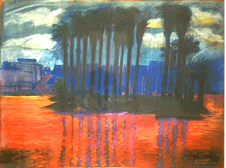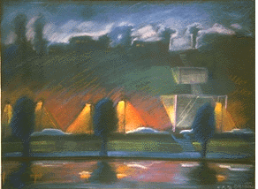
La Tormenta Returns
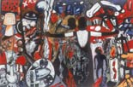
West Coast Crash
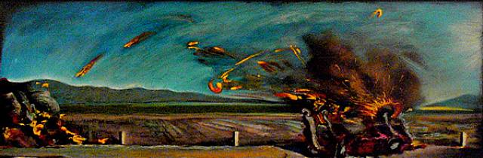
American Tropical
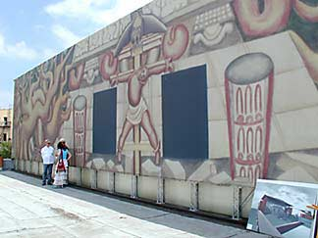

Black and White Mural
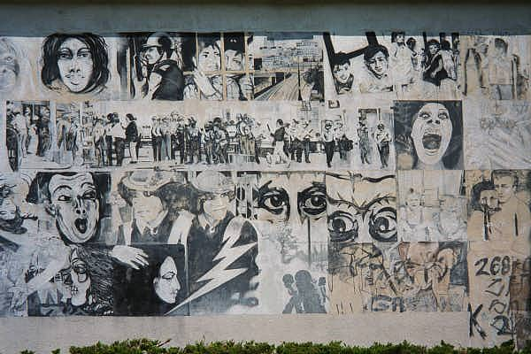
Guernica
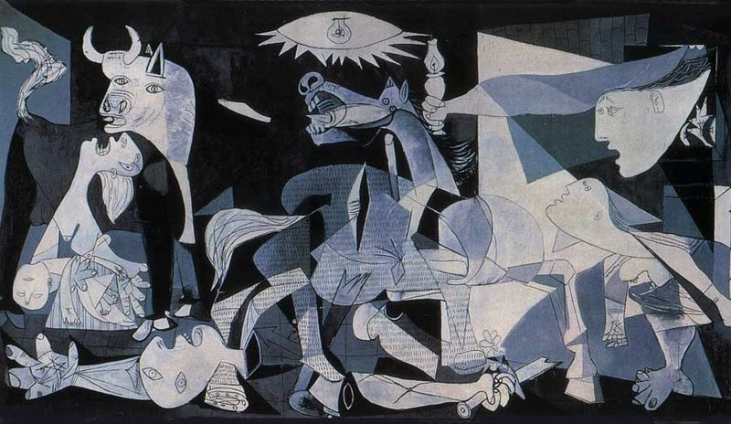

Franz Marc
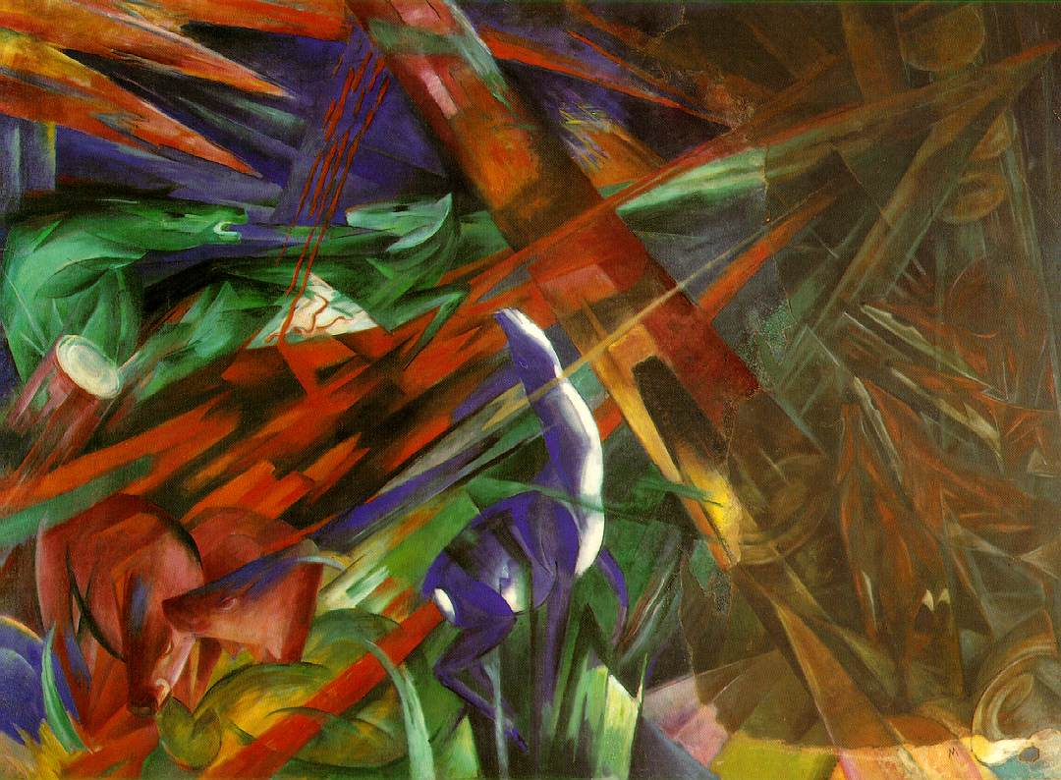
Duchamp’s Fountain


